1[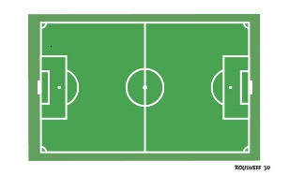](http://www.google.dz/url?sa=i&rct=j&q=&esrc=s&source=images&cd=&cad=rja&uact=8&ved=0ahUKEwishKee1onUAhXGtRQKHZKbAn0QjRwIBw&url=http://eps.roudneff.com/eps/articles.php?lng%3Dfr%26pg%3D105&psig=AFQjCNEEwvz8yX0xnDwuE7XPQDzVZ5fkmg&ust=1495754592460243)2[](http://www.google.dz/url?sa=i&rct=j&q=&esrc=s&source=images&cd=&cad=rja&uact=8&ved=0ahUKEwishKee1onUAhXGtRQKHZKbAn0QjRwIBw&url=http://eps.roudneff.com/eps/articles.php?lng%3Dfr%26pg%3D105&psig=AFQjCNEEwvz8yX0xnDwuE7XPQDzVZ5fkmg&ust=1495754592460243) 9[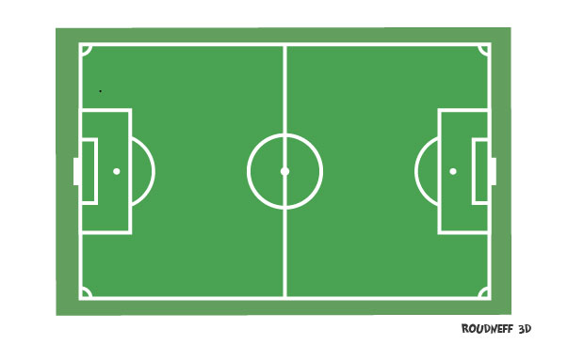](http://www.google.dz/url?sa=i&rct=j&q=&esrc=s&source=images&cd=&cad=rja&uact=8&ved=0ahUKEwishKee1onUAhXGtRQKHZKbAn0QjRwIBw&url=http://eps.roudneff.com/eps/articles.php?lng%3Dfr%26pg%3D105&psig=AFQjCNEEwvz8yX0xnDwuE7XPQDzVZ5fkmg&ust=1495754592460243)10[](http://www.google.dz/url?sa=i&rct=j&q=&esrc=s&source=images&cd=&cad=rja&uact=8&ved=0ahUKEwishKee1onUAhXGtRQKHZKbAn0QjRwIBw&url=http://eps.roudneff.com/eps/articles.php?lng%3Dfr%26pg%3D105&psig=AFQjCNEEwvz8yX0xnDwuE7XPQDzVZ5fkmg&ust=1495754592460243) 11[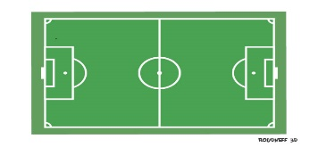](http://www.google.dz/url?sa=i&rct=j&q=&esrc=s&source=images&cd=&cad=rja&uact=8&ved=0ahUKEwishKee1onUAhXGtRQKHZKbAn0QjRwIBw&url=http://eps.roudneff.com/eps/articles.php?lng%3Dfr%26pg%3D105&psig=AFQjCNEEwvz8yX0xnDwuE7XPQDzVZ5fkmg&ust=1495754592460243) 15[](http://www.google.dz/url?sa=i&rct=j&q=&esrc=s&source=images&cd=&cad=rja&uact=8&ved=0ahUKEwishKee1onUAhXGtRQKHZKbAn0QjRwIBw&url=http://eps.roudneff.com/eps/articles.php?lng%3Dfr%26pg%3D105&psig=AFQjCNEEwvz8yX0xnDwuE7XPQDzVZ5fkmg&ust=1495754592460243) 16[](http://www.google.dz/url?sa=i&rct=j&q=&esrc=s&source=images&cd=&cad=rja&uact=8&ved=0ahUKEwishKee1onUAhXGtRQKHZKbAn0QjRwIBw&url=http://eps.roudneff.com/eps/articles.php?lng%3Dfr%26pg%3D105&psig=AFQjCNEEwvz8yX0xnDwuE7XPQDzVZ5fkmg&ust=1495754592460243)

3[](http://www.google.dz/url?sa=i&rct=j&q=&esrc=s&source=images&cd=&cad=rja&uact=8&ved=0ahUKEwishKee1onUAhXGtRQKHZKbAn0QjRwIBw&url=http://eps.roudneff.com/eps/articles.php?lng%3Dfr%26pg%3D105&psig=AFQjCNEEwvz8yX0xnDwuE7XPQDzVZ5fkmg&ust=1495754592460243)4[](http://www.google.dz/url?sa=i&rct=j&q=&esrc=s&source=images&cd=&cad=rja&uact=8&ved=0ahUKEwishKee1onUAhXGtRQKHZKbAn0QjRwIBw&url=http://eps.roudneff.com/eps/articles.php?lng%3Dfr%26pg%3D105&psig=AFQjCNEEwvz8yX0xnDwuE7XPQDzVZ5fkmg&ust=1495754592460243)

5[](http://www.google.dz/url?sa=i&rct=j&q=&esrc=s&source=images&cd=&cad=rja&uact=8&ved=0ahUKEwishKee1onUAhXGtRQKHZKbAn0QjRwIBw&url=http://eps.roudneff.com/eps/articles.php?lng%3Dfr%26pg%3D105&psig=AFQjCNEEwvz8yX0xnDwuE7XPQDzVZ5fkmg&ust=1495754592460243)6[](http://www.google.dz/url?sa=i&rct=j&q=&esrc=s&source=images&cd=&cad=rja&uact=8&ved=0ahUKEwishKee1onUAhXGtRQKHZKbAn0QjRwIBw&url=http://eps.roudneff.com/eps/articles.php?lng%3Dfr%26pg%3D105&psig=AFQjCNEEwvz8yX0xnDwuE7XPQDzVZ5fkmg&ust=1495754592460243) 7[](http://www.google.dz/url?sa=i&rct=j&q=&esrc=s&source=images&cd=&cad=rja&uact=8&ved=0ahUKEwishKee1onUAhXGtRQKHZKbAn0QjRwIBw&url=http://eps.roudneff.com/eps/articles.php?lng%3Dfr%26pg%3D105&psig=AFQjCNEEwvz8yX0xnDwuE7XPQDzVZ5fkmg&ust=1495754592460243)8[](http://www.google.dz/url?sa=i&rct=j&q=&esrc=s&source=images&cd=&cad=rja&uact=8&ved=0ahUKEwishKee1onUAhXGtRQKHZKbAn0QjRwIBw&url=http://eps.roudneff.com/eps/articles.php?lng%3Dfr%26pg%3D105&psig=AFQjCNEEwvz8yX0xnDwuE7XPQDzVZ5fkmg&ust=1495754592460243) 12[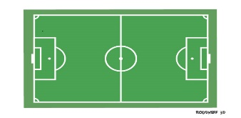](http://www.google.dz/url?sa=i&rct=j&q=&esrc=s&source=images&cd=&cad=rja&uact=8&ved=0ahUKEwishKee1onUAhXGtRQKHZKbAn0QjRwIBw&url=http://eps.roudneff.com/eps/articles.php?lng%3Dfr%26pg%3D105&psig=AFQjCNEEwvz8yX0xnDwuE7XPQDzVZ5fkmg&ust=1495754592460243) 13[](http://www.google.dz/url?sa=i&rct=j&q=&esrc=s&source=images&cd=&cad=rja&uact=8&ved=0ahUKEwishKee1onUAhXGtRQKHZKbAn0QjRwIBw&url=http://eps.roudneff.com/eps/articles.php?lng%3Dfr%26pg%3D105&psig=AFQjCNEEwvz8yX0xnDwuE7XPQDzVZ5fkmg&ust=1495754592460243) 14[](http://www.google.dz/url?sa=i&rct=j&q=&esrc=s&source=images&cd=&cad=rja&uact=8&ved=0ahUKEwishKee1onUAhXGtRQKHZKbAn0QjRwIBw&url=http://eps.roudneff.com/eps/articles.php?lng%3Dfr%26pg%3D105&psig=AFQjCNEEwvz8yX0xnDwuE7XPQDzVZ5fkmg&ust=1495754592460243)